DATA ANALYSIS INTERNSHIP – DAY 20 REPORT
Organization: Top Tech Developers
Topic Covered: Data Analytics, Inspect Element, and CanvasJS

Introduction
Data analytics is the process of collecting, analyzing, and interpreting data to identify useful patterns and insights. Popular platforms such as YouTube and LinkedIn use data analytics extensively to monitor user activities, analyze engagement, and improve recommendations.
On Day 20 of the internship, concepts related to data analytics, browser developer tools, Inspect Element, and CanvasJS were studied and practiced.

1. Data Analytics in YouTube
Website
YouTube
YouTube uses data analytics to analyze user viewing behavior and improve personalized recommendations.

Data Collected
- Video views
- Likes and comments
- Watch time
- Search history
- Subscriber count

Countable Patterns Identified
- Trending videos
- Most viewed categories
- User interests
- Peak watching hours

Example
If many users repeatedly watch cricket highlights, YouTube detects the viewing pattern and recommends similar sports-related videos to users.
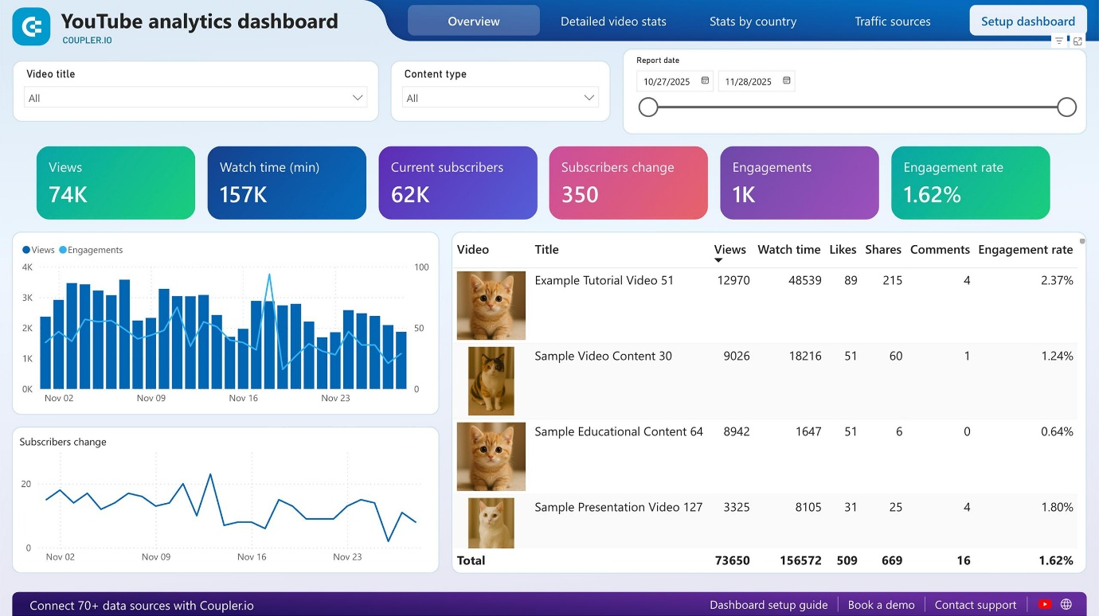
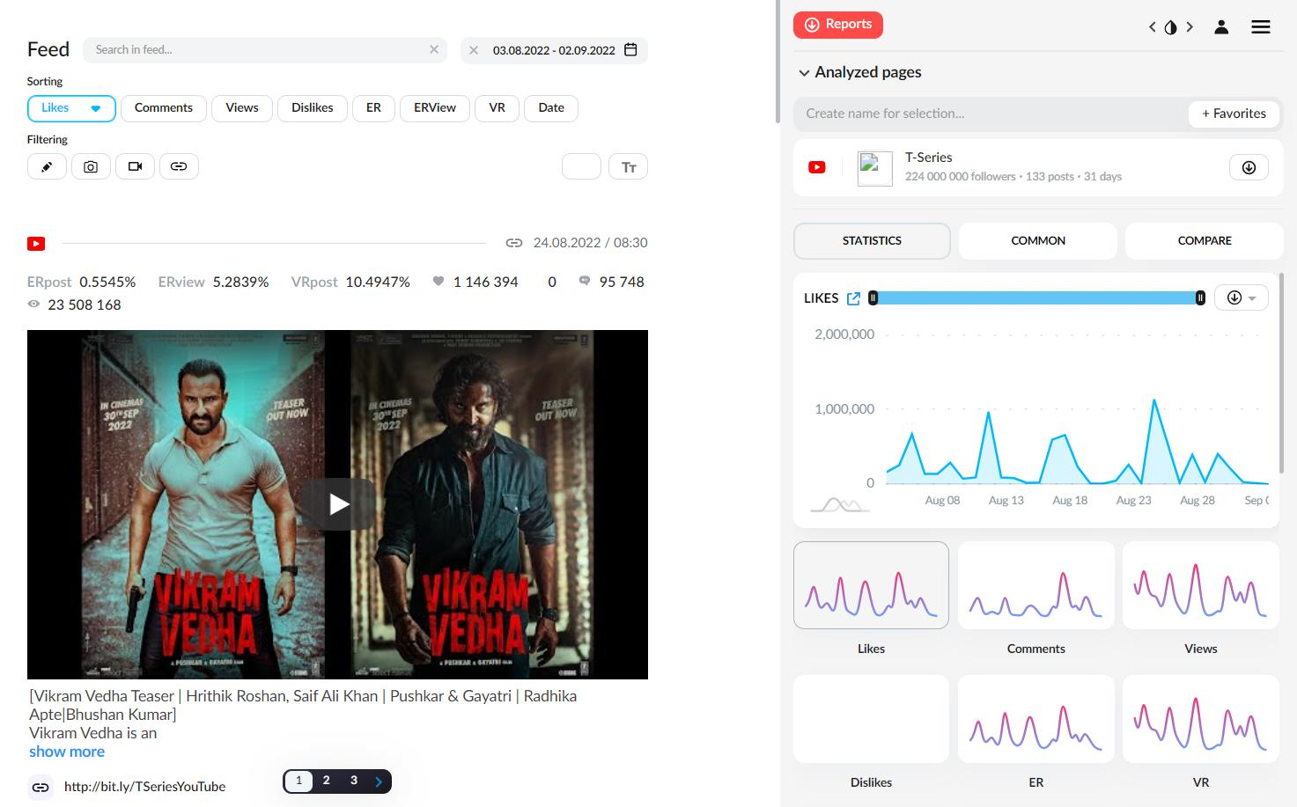



2. Data Analytics in LinkedIn
Website
LinkedIn
LinkedIn uses data analytics to monitor professional activities, job searches, and recruitment trends.

Data Collected
- Profile views
- Job searches
- Skills and endorsements
- Connections
- Post engagement

Countable Patterns Identified
- Most searched skills
- Hiring trends
- User engagement
- Job application frequency

Example
If many users search for “Python Developer,” LinkedIn identifies the trend and recommends related job opportunities and skill-based content.
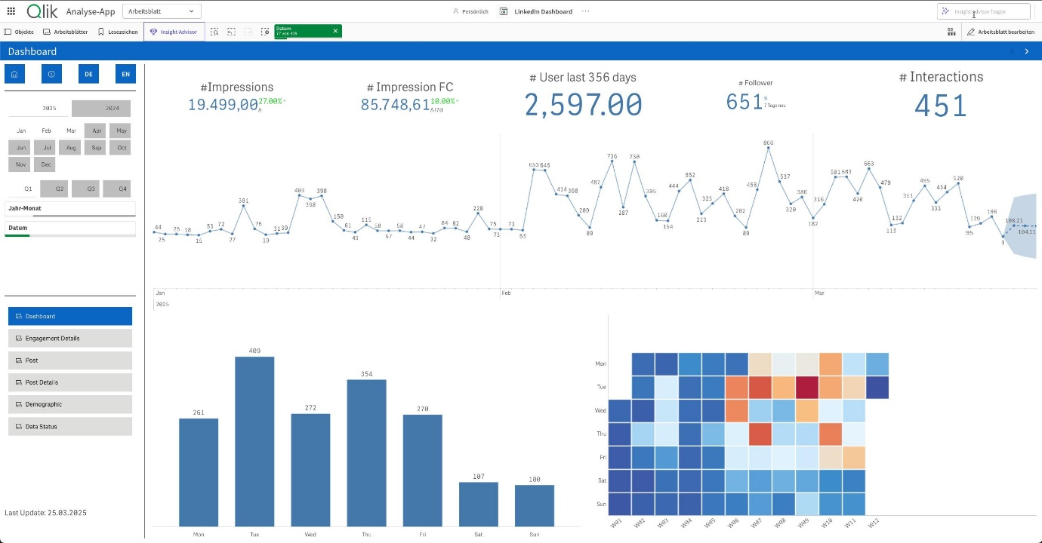
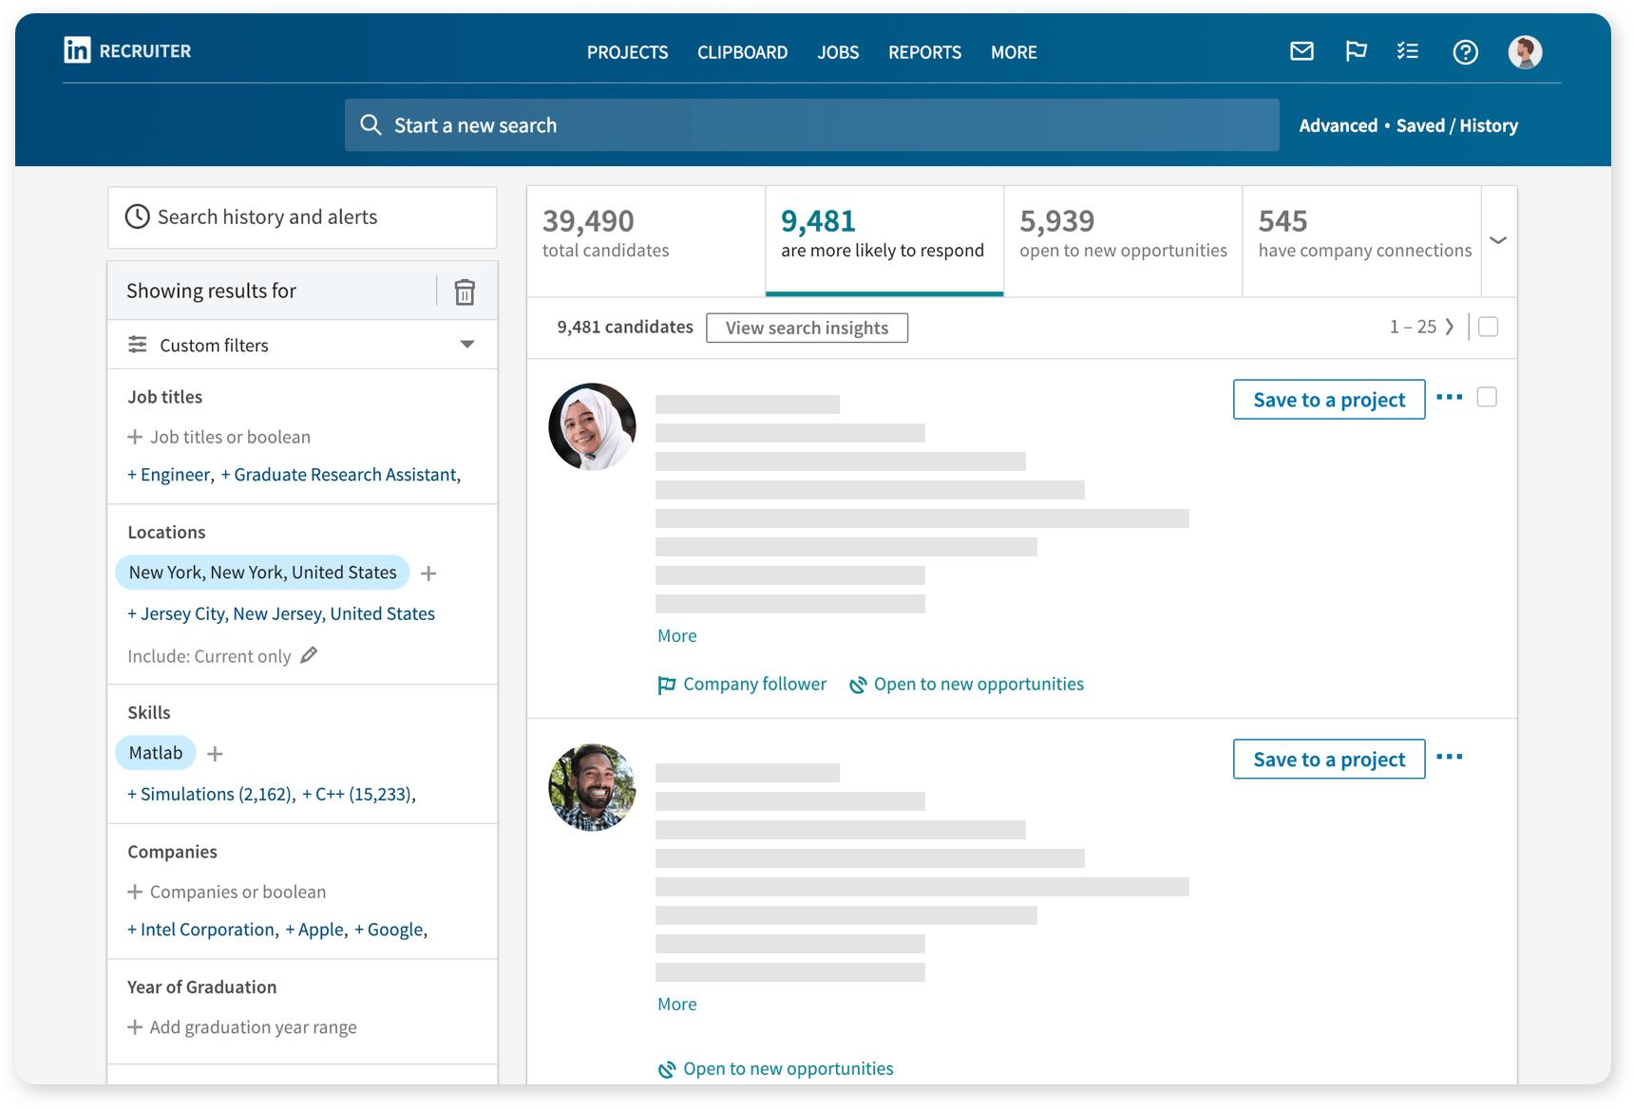

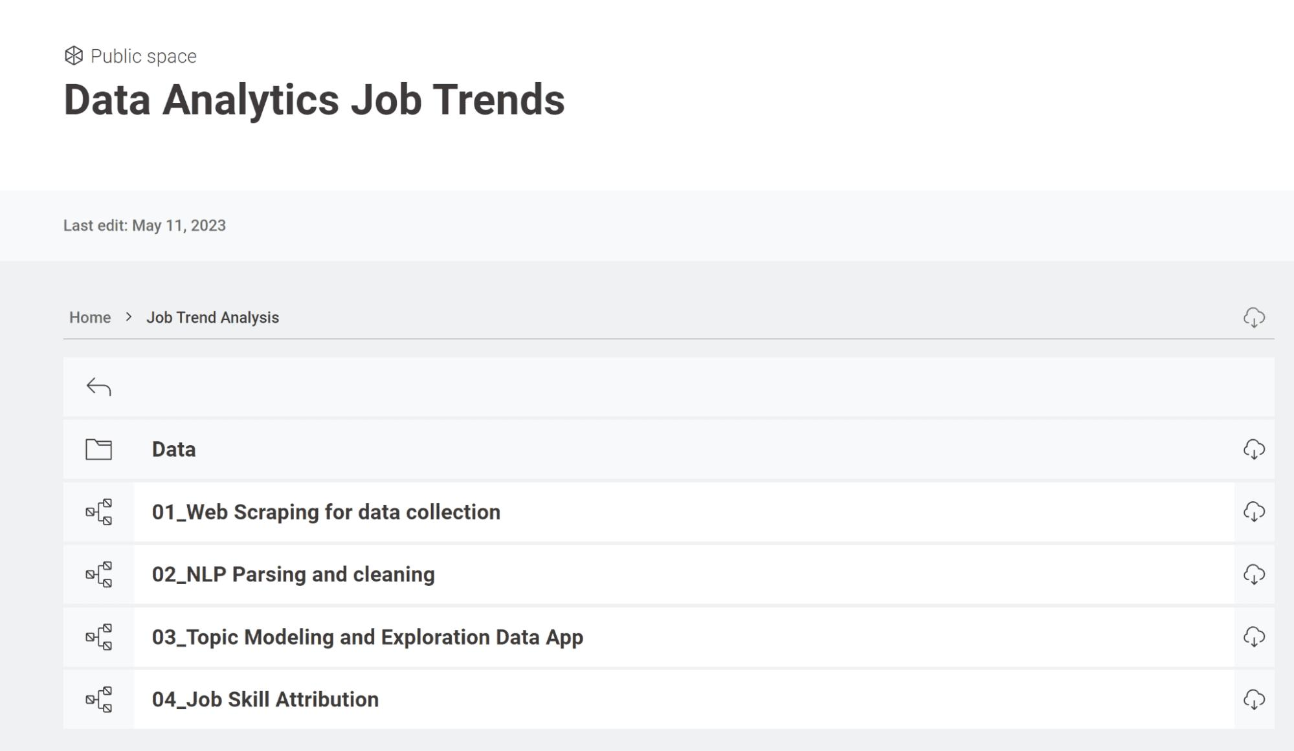

TASK – CanvasJS Task
Introduction
CanvasJS is a JavaScript library used for creating charts and graphs for data visualization. It helps developers build interactive dashboards and visual analytics applications using JavaScript.
In this task, CanvasJS was used to create and analyze charts such as line charts and pie charts.

Website
CanvasJS Official Website

Objectives of the Task
- To understand data visualization using CanvasJS
- To create charts using JavaScript
- To analyze chart rendering using browser Developer Tools
- To convert a line chart into a pie chart
- To verify chart loading using the Network section

Uses of CanvasJS
CanvasJS is commonly used for:
- Displaying analytics
- Creating dashboards
- Visualizing patterns
- Showing statistical data
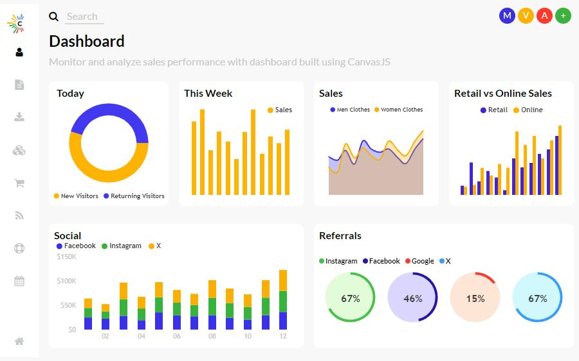
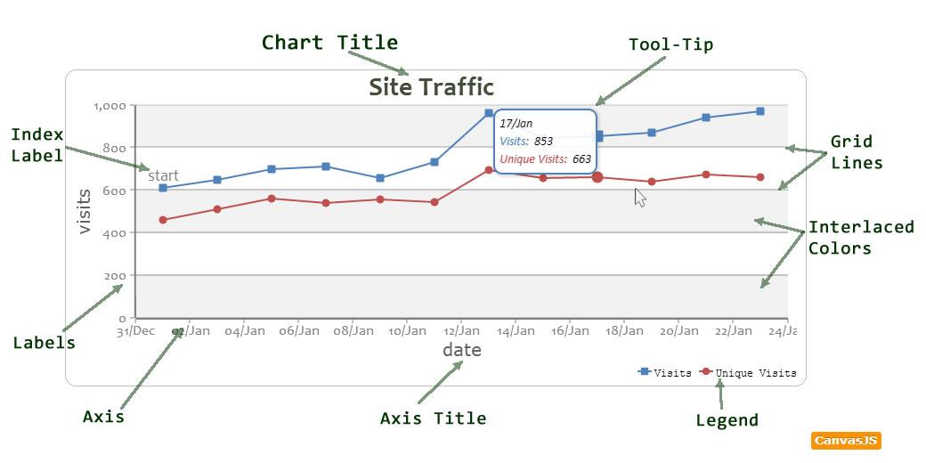
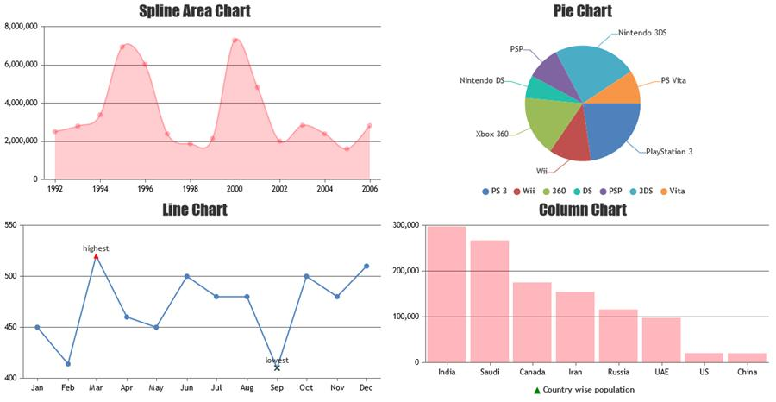
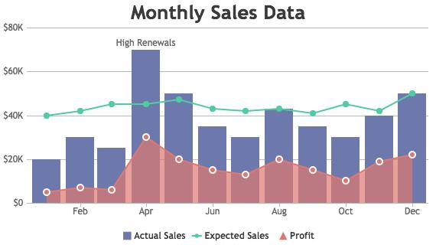
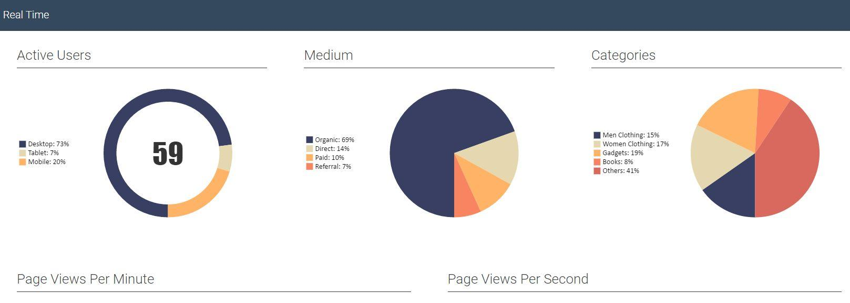
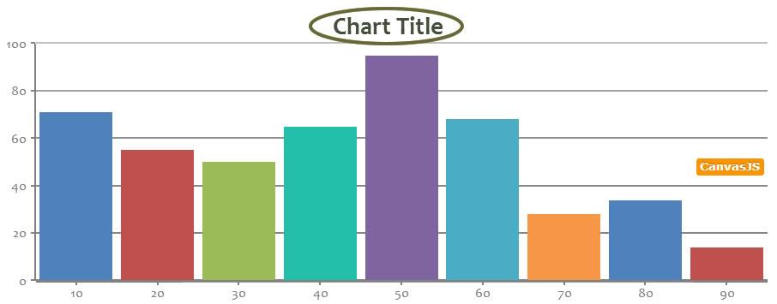
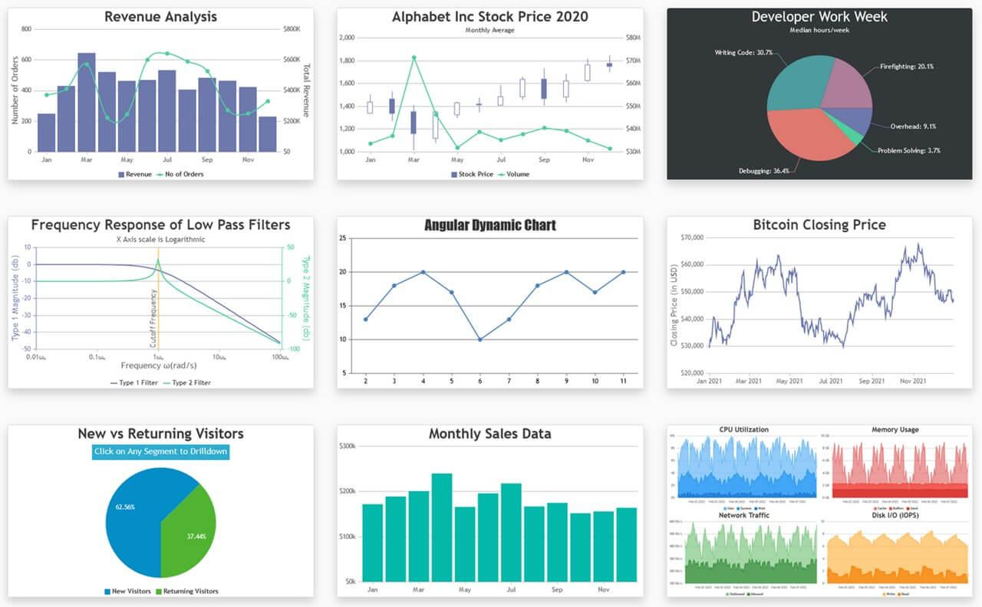


How to Open Inspect Element for CanvasJS
Step 1 – Open CanvasJS Website
Open the CanvasJS chart webpage in a browser.

Step 2 – Right Click on the Chart Page
Right click anywhere on the webpage containing the chart.

Step 3 – Open Network Tab
Open the Network tab inside Developer Tools.

Step 4 – Refresh the CanvasJS Page
Refresh the webpage to load chart requests and resources.

Step 5 – Check CanvasJS Request Status
Find:
- canvasjs.min.js
Check the Status column.
Successful Status Codes
- 200 OK
- 304 Not Modified
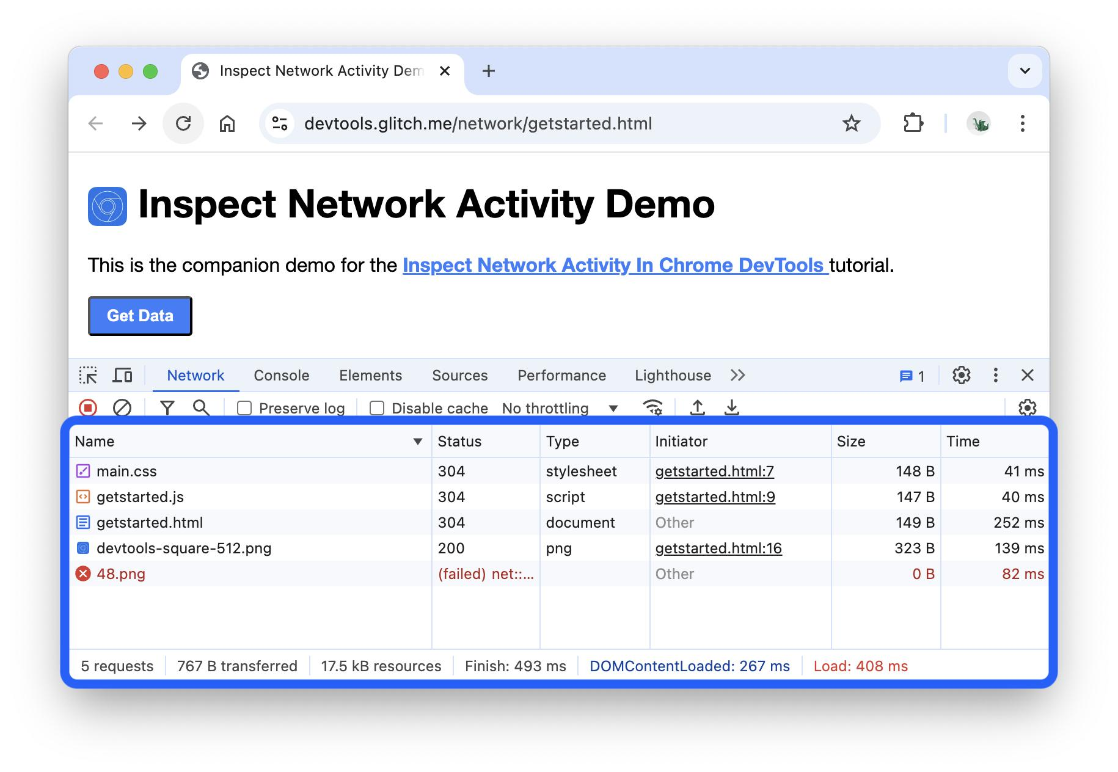
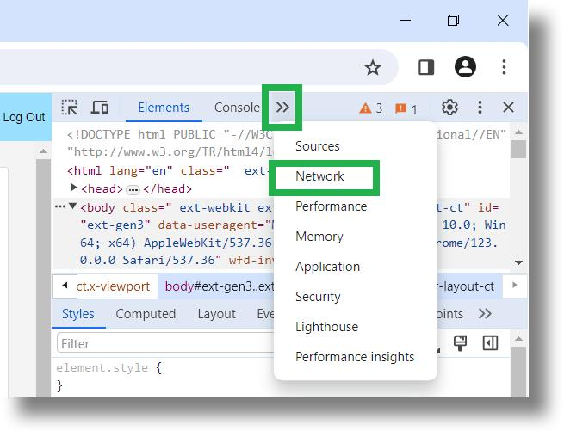

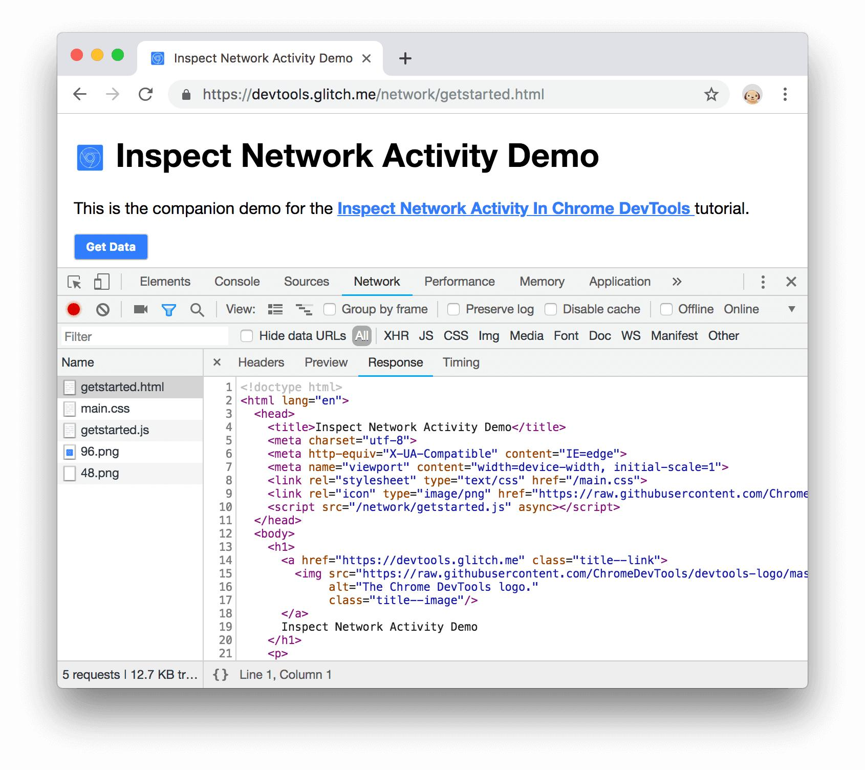
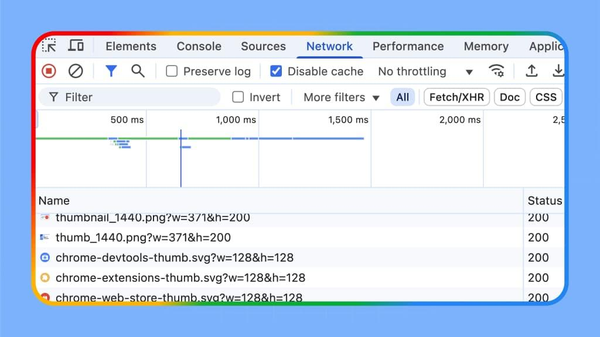

Types of Charts Used
1. Line Chart
A line chart displays continuous trends and changes over time.
Example
type: "line"
Applications
- Sales growth analysis
- Website traffic monitoring
- Student marks analysis
- Performance tracking

2. Pie Chart
A pie chart displays percentage-based data in circular format.
Example
type: "pie"
Applications
- Survey analysis
- Percentage comparison
- Market share analysis
- Student result distribution
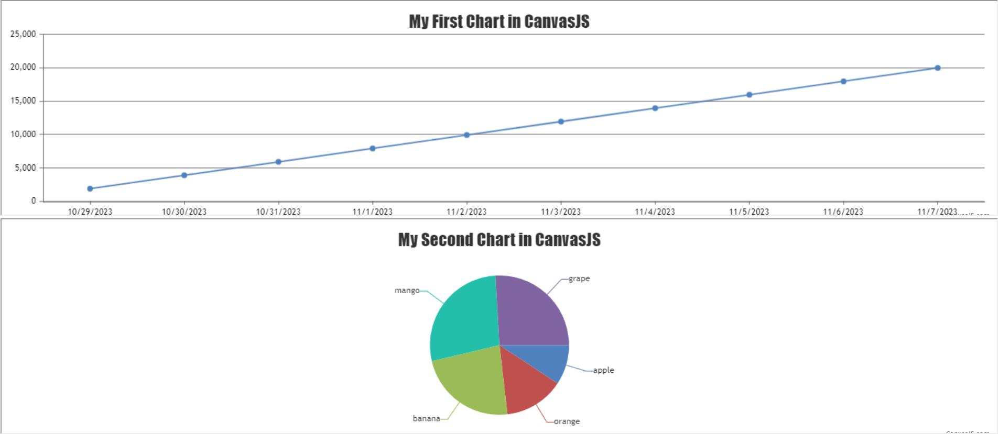
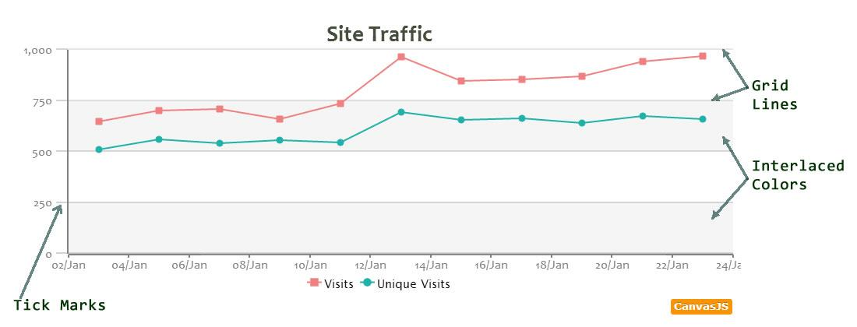
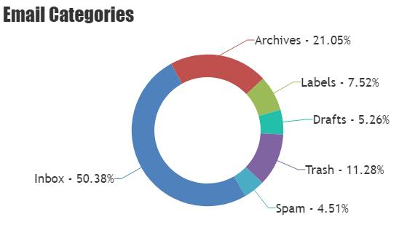
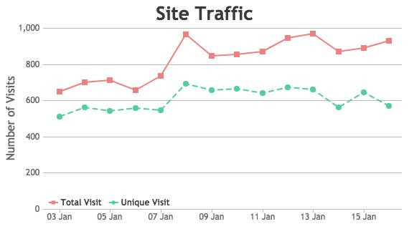
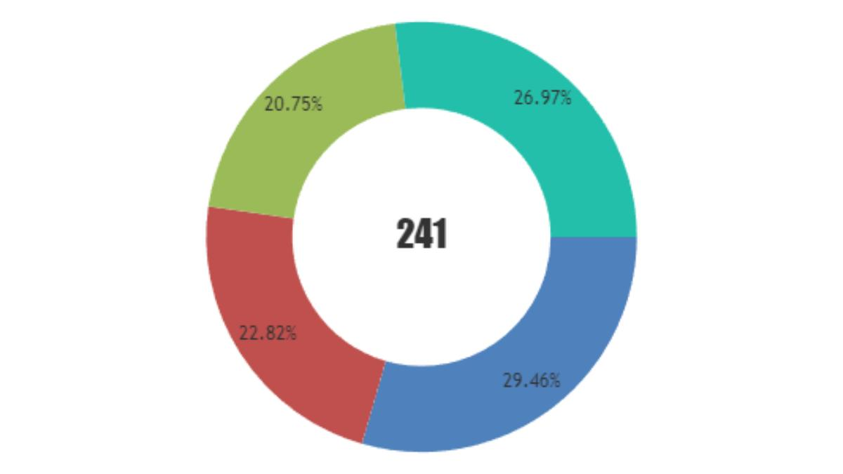


Conversion of Line Chart into Pie Chart
The line chart was converted into a pie chart by modifying the chart type property.
Changed From
type: "line"
Changed Into
type: "pie"
Observation
- The graphical representation changed from connected lines into circular slices
- Data comparison became percentage-based after conversion

Checking Chart Status in Network Section
The Network section in Developer Tools was used to verify whether chart resources loaded successfully.
Steps Performed
- Opened Inspect Element
- Opened the Network tab
- Refreshed the webpage
- Checked the Status column

Status Codes Observed
Status Code | Meaning
200 | Request successful
304 | Not Modified (loaded from cache)
404 | File not found
500 | Internal server error

Technologies Used
- CanvasJS
- JavaScript
- Data Visualization
- Browser Developer Tools
- Network Monitoring
- Data Analytics

Learning Outcome
On Day 20, I learned how data analytics is used in platforms such as YouTube and LinkedIn to analyze user activities and patterns.
I also understood:
- how to create charts using CanvasJS
- how to inspect chart resources using Developer Tools
- how to verify request status codes in the Network section
- how to convert line charts into pie charts
- how charts are used for data visualization and analysis

Conclusion
The Day 20 internship session helped me understand practical applications of data analytics and chart visualization using CanvasJS.
Different chart types such as line charts and pie charts were analyzed and modified successfully. Browser Developer Tools and the Network section were used to inspect chart resources and verify loading status codes such as 200 and 304. This session improved my understanding of analytics, visualization techniques, and web-based chart rendering.

